Problem 1 (30 pts): Two reactants A and B react in the cell cytoplasm to produce two products X and Y. Y is utilized in a subsequent reaction as fast as it is produced, so that its concentration remains virtually zero. That makes the reaction irreversible. The irreversible chemical reaction equation is
$A+B \underset{→}{k} X+Y$
Let a, b, x, and y denote the respective concentrations of each substance. Assume that the initial concentrations are: a₀ = 10.5 $μg/ml$, b₀ = 6.5 $μg/ml$, x₀ = 0, y₀ = 0. The rate of reaction constant is k = 2.0/s.
You have to take into consideration conservation of mass.

- Assess each of the statements below, say whether the statement is true or false and substantiate with logical explanation.
  - The model of the reaction kinetics is $\frac{dx}{dt}=2\left(10.5-x\right)\left(6.5-x\right):$ (True/False)
True this model equation accurately describes kinetics defining a=10.5-x, and b=6.5-x, with a rate constant of k=2.0/s
  - The model of the reaction kinetics is $\frac{dx}{dt}=2\left(10.5-x\right)\left(6.5-y\right):$ (True/False)
False this model equation in accurately describes a separate variable y, which means we can’t assume conservation of mass.
  - Reactant A gets depleted first. (True/False)
Since A_0 > B_0 (10.5 >6.5) Reactant B is the limiting reactant will be fully used first
- Next, create a Simulink simulation of the correct model.
- Finally solve the differential equation of the correct model using Matlab symbolic language
- % Define symbolic variable and differential equation
- syms x(t)
- a0 = 10.5; b0 = 6.5; k = 2.0;
- dx_dt = k * (a0 - x) * (b0 - x);

- % Solve the differential equation
- solution = dsolve(diff(x, t) == dx_dt, x(0) == 0);
- disp('The solution for x(t) is:');
- The solution for x(t) is:
- disp(solution);
- 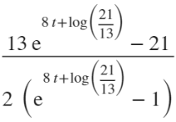

- % Simplify and plot the solution
- simplified_solution = simplify(solution);
- figure('color', 'w');
- fplot(simplified_solution, [0, 5]);
- title('Concentration of Product X over Time');
- xlabel('Time (seconds)');
- ylabel('Concentration of X (\mug/ml)');
- grid on;
- 

Problem 2 (40 pts)
(see diagrams below)
Consider the following irreversible intracellular reaction in which one mole of X reacts with one mole of Y to create one mole of Z with forward rate constant of k₁. Denote the concentrations of X, Y and Z as x, y and z (respectively). Both X and Y diffuse into the cell from the extra-cellular fluid (ECF) with diffusion coefficients of k_{x} = 2 $\frac{μg}{sec}$and k_{y} = 3 $\frac{μg}{sec}$ (respectively). Extracellular X and Y are carried by albumin and there is a large reservoir of each in the carrier state. We are only interested in the free X and Y. Because there is a large reservoir, we can assume that the concentrations of free X and Y in the extracellular fluid are constant and equal x_{0e} = 10$μg/mg$ and y_{0e} = 6 $μg/mg$. Assume that the initial conditions for all intra-cellular fluid (ICF) reactants and product are zero: x_{0 i}= y_{0i} = z_{0i} = 0.
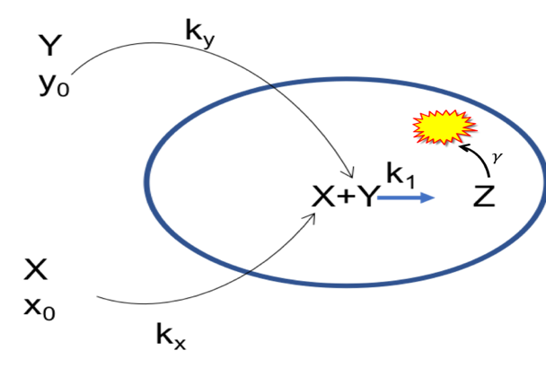Also we know that the product of this reaction, Z, is consumed by a subsequent reaction in the cell proportionate to its concentration with a proportionality constant of $γ=2/sec$
Furthermore, there is a negative feedback mechanism where z, the concentration of Z, inhibits the forward progress of the reaction, X+Y Z, in the following way: $k_{1}=α-βz$ and k₁ is always $≥0$ (see graph)
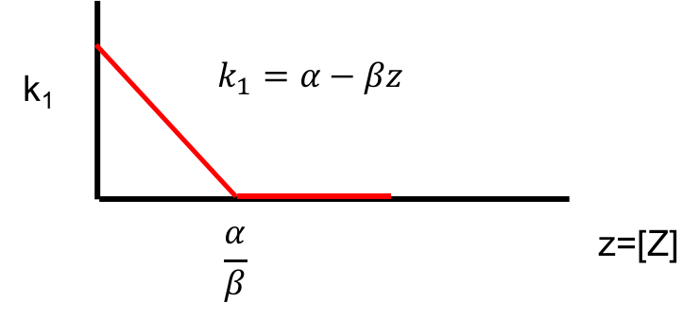
Let $α=10 \& β=2. Clearly, as z→\frac{α}{β} , k_{1}→0 and the reaction will stop if k_{1}=0$
Write the dynamical system that describes this situation (differential equations)
- Create the Simulink model for a numerical solution. Run the model for 5 seconds. Present your output (don’t forget labels, title, etc.). The presence of Z inhibits its own production, but Z is also consumed thus reducing its presence
- Identify equilibrium point(s). What are they (numerical values)?
- What happens to k₁? Does it go to zero? If not, what is its final value
- Does the operation stop or just reach a steady state?

clc; clear; close all;

% Parameters
kx = 2; ky = 3; gamma = 2;
alpha = 10; beta = 2;
x0_e = 10; y0_e = 6;

% Initial conditions
x0 = 0; y0 = 0; z0 = 0;
t_end = 5; dt = 0.01;
t = 0:dt:t_end;

% Initialize variables
x = zeros(size(t)); y = zeros(size(t)); z = zeros(size(t));
x(1) = x0; y(1) = y0; z(1) = z0;

% Euler Method Simulation
for i = 1:length(t)-1
k1 = max(0, alpha - beta * z(i)); % Enforce k1 >= 0
dx = kx * (x0_e - x(i)) - k1 * x(i) * y(i);
dy = ky * (y0_e - y(i)) - k1 * x(i) * y(i);
dz = k1 * x(i) * y(i) - gamma * z(i);

% Update values
x(i+1) = x(i) + dt * dx;
y(i+1) = y(i) + dt * dy;
z(i+1) = z(i) + dt * dz;
end

% Plot results
figure;
plot(t, x, 'r', 'LineWidth', 2); hold on;
plot(t, y, 'b', 'LineWidth', 2);
plot(t, z, 'g', 'LineWidth', 2);
xlabel('Time (seconds)');
ylabel('Concentration');
legend('X (Reactant)', 'Y (Reactant)', 'Z (Product)');
title('Time Evolution of Concentrations');
grid on;


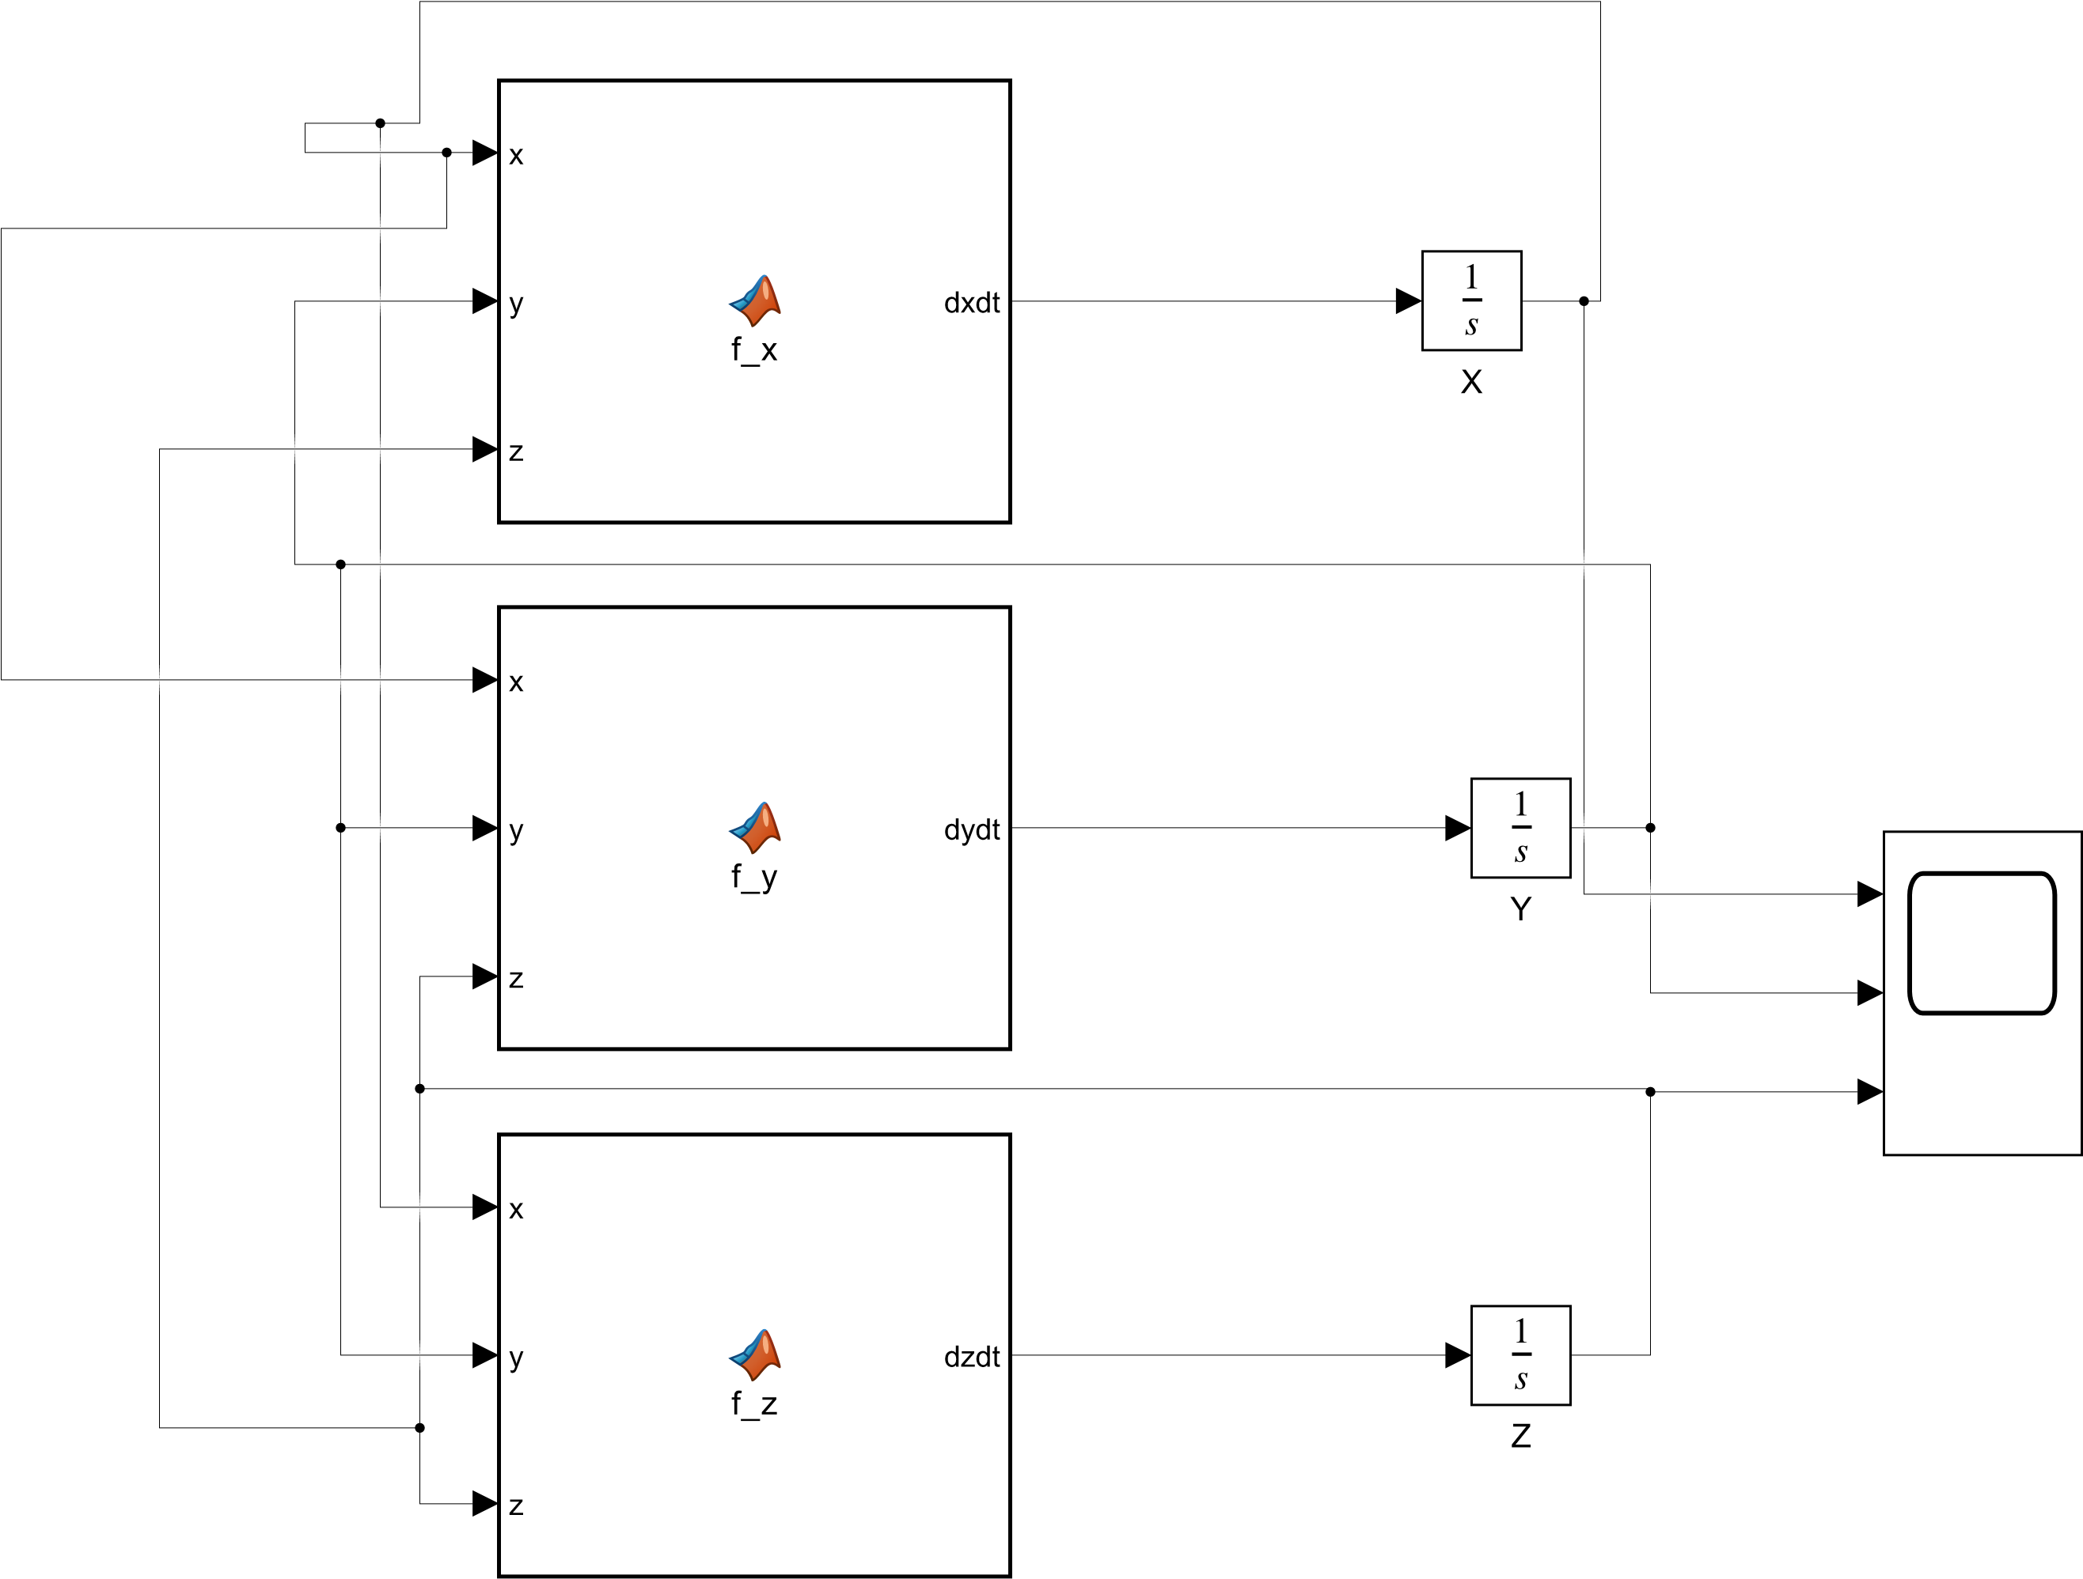
Problem 3 (30 pts)

A nerve cell has the following ionic concentrations inside and outside the cell:

Inside | Outside
Na⁺ 14 mMol | 140 mMol
K⁺ 140 mMol | 4 mMol

The measured membrane potential = -79.3 mV.
Note that R = 8.3 J/K,
temperature = 37⁰C,
F = 96500 C/mole
Z=1 for both ions
$2.303\frac{RT}{ZF}=61.5$ using log base ten
Assume that Na+ and K+ are the only permeable ions.
The ratio of gNa:gtotal = 0.1,
the ratio of gK:gtotal = 0.9

ion conductance for each ion is a constant and does not change with changing ion concentrations.
- Calculate what happens to the membrane potential if extracellular K⁺ is increased by 25 mM. Show your work.
(Note this problem can be solved with pencil, paper, & calculator, with Matlab command window – be sure to use the correct log function - , or on Excel equally easily)

- Research the concept of membrane voltage threshold and action potentials.
  - Write a short essay explaining what this entails.
  - The extracellular potassium ion level can be suddenly increased by 25 mMol/L, say by intravenous injection of KCl. Why do you think that this will be a lethal injection?

